Predictive Models in ICU Databases: Balanced vs. Real-World Distributions - A Machine Learning Analysis on ICU Outcome Prediction
Mariah Noelle Cornelio, Darlene Eligado, Alain Areeba Siddiqui
DATA 4381: Data Capstone Project 1
Project Advisor: Dr. Masoud Rostami
December 8, 2025

Introduction and Background
The Intensive Care Unit (ICU) is an important hospital environment where patients with life-threatening conditions receive continuous monitoring, advanced treatments, and rapid interventions. Because these patients often experience sudden changes in their health status, early identification of individuals at high risk for poor outcomes (such as in-hospital mortality or readmission) is essential for improving care and allocating resources effectively. However, ICU datasets present major challenges for predictive modeling. Most notably, poor outcomes occur far less frequently than good outcomes, resulting in a highly imbalanced class distribution. This imbalance causes machine learning models to favor the majority class and overlook the minority class, even though identifying high-risk patients is the main clinical priority. Traditional evaluation metrics and default probability thresholds also fail under imbalance, creating a misleading impression of model performance.
To address these challenges, our project investigates the research question: Can we predict ICU patient poor outcomes (death or readmission) using demographic, clinical, and physiological data, and how does imbalance affect model performance? We approach this through three complementary sub-objectives: (1) determining whether models trained on imbalanced data perform differently from those trained on balanced data (Mariah), (2) examining the trade-offs that arise when preserving real-world class prevalence for greater clinical realism (Alain), and (3) evaluating the sacrifices made when optimizing a model solely for its best predictive performance, regardless of real-world class frequencies (Darlene). Collectively, these objectives provide a comprehensive understanding of how imbalance, resampling strategies, and threshold adjustments influence model behavior, ultimately guiding approaches that better support clinical decision-making in the ICU.
Data Understanding
The dataset used in this project originates from the eICU Collaborative Research Database Demo hosted on PhysioNet (version 2.0.1). The Demo set contains 31 relational tables, each storing different aspects of patient information such as demographics, laboratory results, vital signs, clinical scores, interventions, and hospital unit details. For the purposes of this study, we selected a subset of clinically relevant tables; specifically patient, apachePatientResult, apacheApsVar, apachePredVar, intakeOutput, and vitalPeriodic. These tables were merged using the shared key “patientunitstayid” to create a consolidated analytical file, mergeICU_db.csv, which served as the foundation for all exploratory analysis and modeling.
The resulting merged dataset consists of 2,520 patient rows and 55 feature columns that span demographic variables, physiological measurements, and disease severity indicators. Among these features were age, gender, and ethnicity, as well as various APACHE predictor variables and vital signs such as heart rate, oxygen saturation, bilirubin, creatinine, and urine output. This structure enabled us to treat each ICU stay as a distinct observation, allowing for a comprehensive modeling approach that integrates both static demographic information and dynamic physiological data.
The prediction target for this project was a combined binary outcome variable called bad_outcome, which captured whether a patient experienced either ICU mortality or ICU readmission. A value of 1 indicated a poor outcome, while 0 represented a good outcome. Based on the merged dataset, 2,227 patients (88.3%) had a good outcome, and only 293 patients (11.6%) experienced a bad outcome. This distribution highlights a clear class imbalance, a characteristic that is common in critical care datasets because adverse events, while important, are relatively rare. This imbalance played a key role in later model development and evaluation.
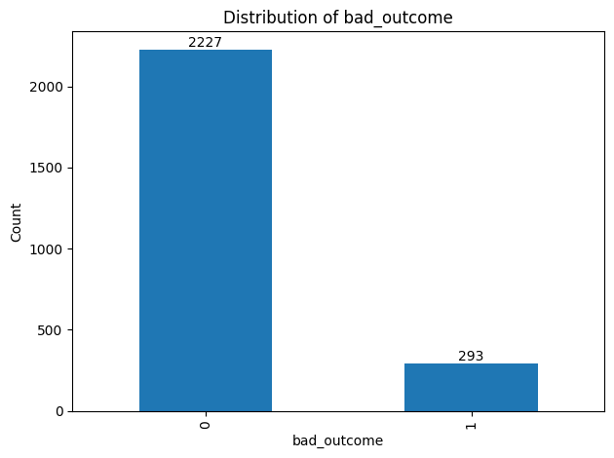
Figure 1. Distribution of target variable bad_outcome (mortality and readmission)
Exploratory Data Analysis (EDA) revealed several important characteristics of the dataset. First, some variables were assigned inappropriate data types; for example, the age variable was loaded as an object rather than a numeric feature, causing it to be interpreted as a categorical variable. Despite this, the dataset contained no duplicate patient entries. Missingness varied widely across features, with some variables like electivesurgery and dischargeweight containing approximately 86% and 50% missing data, respectively. Several laboratory variables used “-1” to denote “not recorded,” which is common in ICU charting systems but required special handling in the preprocessing stage.
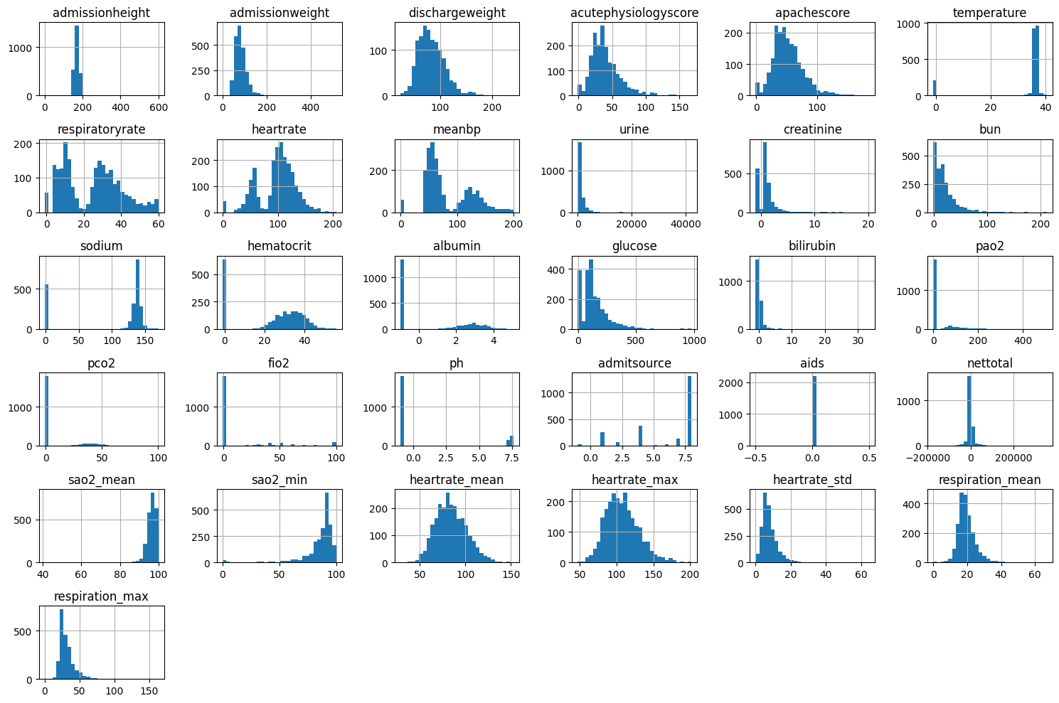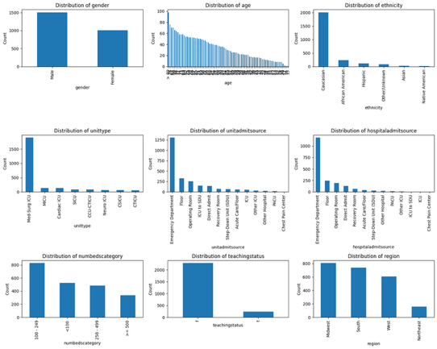
Figure 2. Numerical (left) and categorical (right) distribution of features during EDA
Distributional analyses of numerical variables showed that many features followed an approximately normal pattern with slight right skew, alongside a substantial number of extreme values. These outliers were expected in ICU settings due to severe physiological disturbances and were therefore retained as clinically meaningful observations rather than statistical noise. Demographic analyses showed that the majority of patients were Caucasian, with males slightly outnumbering females. When examining outcome rates across demographic groups, Asian patients exhibited the highest proportion of bad outcomes, followed by Hispanic, Caucasian, and African American patients. Male and female patients exhibited similar bad outcome rates. Additionally, the correlation matrix revealed that the variable indicating AIDS status had a constant value of zero, meaning no patients in this dataset had AIDS. As such, it held no predictive value and could be safely removed during preprocessing.
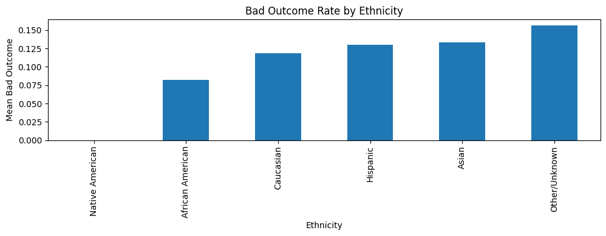
Figure 3. Bad outcome rate by ethnicity example
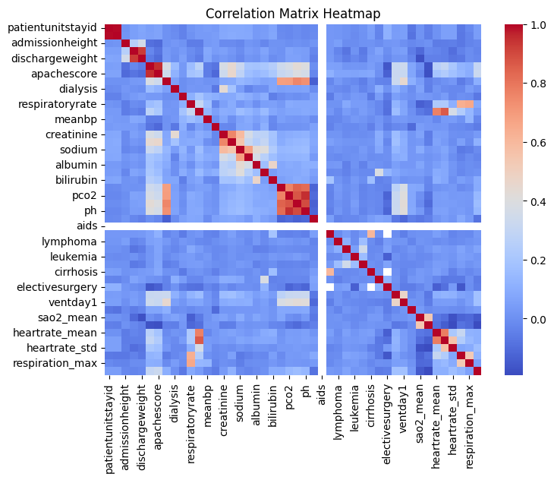
Figure 4. Correlation matrix heatmap of numerical features during EDA
Overall, the dataset presents a realistic portrayal of ICU patient populations: heterogeneous in composition, clinically noisy, and affected by significant missingness and class imbalance. These characteristics necessitated careful preprocessing and informed the methodological choices made in the modeling stages that follow.
Data Preprocessing
Before model development, extensive preprocessing was performed to ensure data quality, reduce bias, prevent leakage, and prepare features for machine learning algorithms. Because ICU data are clinically complex and contain substantial missingness and redundancy, each preprocessing step was guided by medical interpretability and modeling best practices. First, features irrelevant to the research question like teachingstatus and numbedscategory were removed. We also assessed overlapping admission-related variables (unitadmitsource, hospitaladmitsource, admitsource) and kept only admitsource to avoid redundant predictors. Several columns displayed no variance, including the aids feature, which contained only zeros; these were dropped. Data leakage was also identified and removed, such as dischargeweight and acutephysiologyscore, which contain post-admission or outcome-related information that would artificially inflate model performance.
Missing data required special attention due to the clinical nature of the dataset. Many laboratory and physiological variables used –1 to indicate “not recorded”, which is distinct from a true value of zero. All –1 entries were therefore replaced with “NaN: to accurately reflect missingness. For numeric features, missing values were imputed using the median, chosen over the mean because it is robust to the heavy right-skew and clinically extreme outliers typical in ICU physiology. For categorical variables, missing entries were replaced with the label “Unknown” to avoid fabricating unrealistic categories. In addition, for features with extensive missingness, missingness flags were created (Example: creatinine_missing = 1 if NaN else 0) to preserve clinically meaningful patterns, as absence of lab testing can itself correlate with patient severity.
Data type corrections were also performed, including converting the age column from an object type to numeric and setting variables such as admitsource to categorical. All relevant categorical predictors (like ethnicity and gender) were then transformed using one-hot encoding. During feature cleaning, multicollinearity was assessed using Variance Inflation Factors (VIF), leading to the removal of highly redundant variables such as heartrate_max, heartrate, respiration_max, sao2_min, pco2, and fico2, which were strongly correlated with each other and with other vital signs that captured the same physiological information more efficiently. Low-representation ethnicity groups were combined into a single “Other” category to reduce noise and maintain statistical power.
Finally, two modeling datasets were produced: a scaled version using standardization for algorithms sensitive to feature magnitude (SVM, logistic regression), and an unscaled version for tree-based methods (Random Forest, XGBoost). Together, these preprocessing steps ensured that the dataset was medically accurate, statistically clean, and appropriate for fair comparisons of imbalanced and balanced model performance.
Methodology and Planned Modeling
Objective 1
- 2 scenarios
  - Scenario 1: train on imbalance
  - Scenario 2: train on balanced
- 6 models each scenario (so 12 total)
  - LR, RF, XGBoost, SVM, LightGBM, Custom Stacked Model with LR + XGB as base models and LR as meta-learner
  - 80-20 tran test split and stratified k-fold cross-validation for all models
  - Focus on Recall > F1 > Precision and PR-AUC and ROC-AUC
Objective 2
Objective 2 emphasizes the realism of our models and how we can deploy these models with the context of complex ICU environments.
- Perform extensive data exploration to understand where the gaps are between
- Develop models that account for robust imbalance using the two different scenarios mentioned in Objective 1
- Focus on success metrics that are relevant to specifically error analysis including AUROC, calibration, subgroup performance, sensitivity at significant thresholds for this dataset
- Rework subgrouped models to focus on minority demographics that might be leading to lower overall success metrics
- Implement adaptive error analysis into our main models to catch errors while predicting outcomes.
Objective 3
Objective 3 focuses on how different imbalance‑handling strategies change the trade‑offs when predicting ICU mortality and readmission, where the target variable bad_outcome indicates whether a patient has died in the ICU (1) or survived (0). The two modeling pipelines both use Random Forest and XGBoost, and only differ on how they handle the minority bad_outcome class, which is consistent with recent ICU mortality modeling work using tree-based methods (Iwase et al., 2022; Safaei et al., 2022). This setup makes it easier to see how performance and clinical behavior shift when using SMOTE oversampling compared with using class-weighting while maintaining the original outcome imbalance (Safaei et al., 2022).​​
Both approaches run on the same preprocessed merged ICU dataset, which combines demographics, APACHE based severity information, and key 24-hour vital signs and lab values for about 2,500 ICU stays (Johnson et al., 2021). In the first pipeline, the training set is re-balanced using SMOTE, which creates synthetic bad_outcome patients so the model sees more examples of the minority class during training (Safaei et al., 2022). In the second pipeline, the original imbalance distribution is kept as is, and instead of using the models use class weights balanced so that misclassifying a bad_outcome patient is penalized more heavily than misclassifying a patient that survived, an approach that has been used in ICU and emergency department risk prediction models (Yun, Choi, & Park, 2021). Aside from this difference, both pipelines share the same train-validation-test split (70/15/15), feature set, and model hyperparameters so that any changes in results can be traced back to the imbalance strategy rather than to unrelated modeling decisions.
After training each model, predicted probabilities on the test set are turned into class labels using a full threshold sweep from 0.01 to 0.99 instead of the default 0.50 cutoff similar to threshold optimization strategies used in dynamic ICU mortality risk tools (Kawasaki et al., 2020). For each threshold, standard metrics, such as recall, precision, accuracy, F1–score, and ROC based measures are calculated, with particular attention to how recall for the minority class improves or declines as the threshold moves (Safaei et al., 2022). This kind of threshold tuning is motivated by previous ICU mortality studies, showing that a single default cutoff can hide high-risk patients, and that adjusting the threshold can reveal additional important cases that would otherwise be classified as low-risk (Ali et al., 2025; Zhang et al., 2025).
To connect these patterns back to practical use, a “best predictive performance” operating point is then chosen for each model and imbalance strategy. For this specific objective in the project, the best point is defined as the threshold that maximizes F1–score while staying close to the highest achievable recall, reflecting that missing a true bad_outcome case is usually more harmful than flagging an extra false positive (Ali et al., 2025). This choice is based on earlier ICU and cardiovascular studies suggesting that it is often better for an early-warning tool to catch more true high-risk patients, even if that means raising the numbers of false positives, because clinicians can sort those out during normal triage (Zhang et al., 2025).
Finally, the SMOTE-based models and class-weighted models are compared at their chosen threshold point, using confusion matrices, overall metrics, and feature importance plots. In general, SMOTE is expected to help the model catch more true bad_outcome cases but can also create more false positives and make deaths and readmissions appear more common than they really are, whereas class weighting keeps overall outcome rates closer to the real ICU prevalence, but may still miss some high-risk patients (Iwase et al., 2022; Yun et al., 2021). Looking at these results side-by-side makes it clear what is being given up when the model is tuned only to push performance numbers as high as possible, instead of keeping predictions closely aligned with how often bad outcomes actually occur in the ICU.
Challenges and Reflection
Objective 1
Challenges
- Handling clinically meaningful missingness (–1 values → NaN + missingness flags).
- Maintaining clinical accuracy while preprocessing (imputation, encoding, “Unknown” categories).
- Managing multicollinearity among correlated vitals using VIF + medical judgment.
- Addressing severe class imbalance (293 vs. 2227) and choosing between SMOTE, class weights, or natural distribution.
- Avoiding data leakage from post-outcome variables (e.g., dischargeweight, acutephysiologyscore).
Reflection
- Learned how preprocessing choices directly affect clinical validity, not just model performance.
- Improved ability to balance statistical methods with medical reasoning.
- Recognized how easy it is for shortcuts to create unrealistic or misleading clinical patterns.
- Gained stronger justification skills for each step of the modeling pipeline.

Objective 2
The main challenge in Objective 2 is the significant class imbalance across demographic groups, which can distort model performance and lead to biased prediction outcomes. When certain populations, such as minority groups, are underrepresented, the model may generalize poorly and produce less reliable predictions for those individuals. Addressing this imbalance often raises the question of whether to use synthetic data to increase representation. However, synthetic augmentation comes with concerns about realism, potential overfitting to artificially generated patterns, and ethical implications related to fairness, transparency, and the risk of misrepresenting vulnerable populations.
It became clear that considering the patient as a whole, and especially minority groups as a whole, is essential. The patterns hidden within this dataset are complex, and imbalanced datasets often hide these patterns, making them very difficult to detect. Maintaining dataset integrity requires careful attention to which data are added or removed so that model outcomes are not unintentionally skewed. Using machine learning methods to uncover and interpret these discrepancies provides so much more meaningful insight than it may initially appear. Effective error analysis also demands more than simply evaluating a model; it requires a clear understanding of the specific targets, the context behind each outcome, and what should be defined as an error.

Objective 3
A major challenge in objective 3 was the extreme class imbalance in ICU outcome, where the true bad_outcome cases were much rarer than survivors (293 vs. 2227). This causes the early baseline models to look accurate while missing nearly all high-risk patients, a common issue in clinical machine learning. Using SMOTE increased representation of the minority class but the synthetic cases sometimes amplified patterns not present in the original data. Class-weighting maintained real ICU prevalence but still struggled to consistently detect tru positive cases. Working through these issues highlighted that imbalance-handling is never neutral. Each method changes how the models interpret risk and affects both sensitivity and how well the predictions reflect real ICU populations.
Threshold selection also proved difficult. Because the minority class was so small, even small shifts in the cutoff made large changes in recall, precision, and F1, making the default 0.50 threshold unusable. The threshold sweep showed that maximizing F1 often required accepting more false positives, while more conservative thresholds missed too many true deaths. Comparing SMOTE-based and class-weighted models at their optimized thresholds made trade-offs clear. Pushing for the “best” performance can distort real-world outcome frequencies, while more realistic thresholds may sacrifice sensitivity. These reflections reinforced that performance metrics alone can hide practical clinical considerations, and will guide us into Capstone 2 as the project moves forward.
Results and Insights
Objective 1
- 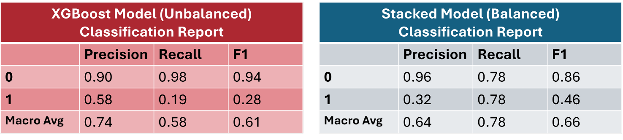
  - Unbalanced training achieved high accuracy but poor sensitivity, missing many bad-outcome cases.
  - Balanced training improved recall, ROC-AUC, and PR-AUC, with confusion matrices showing fewer false negatives.
- Both model types consistently highlighted clinically meaningful severity markers.
Objective 1 compared an XGBoost model trained on the original imbalance data with a stacked ensemble model trained on a balanced version of the dataset. In the imbalance setting, the XGBoost model achieved very high performance for the majority class (survivors), with a precision 0.90, recall 0.98 and F1-score 0.94 for class 0, but performed poorly for bad_outcome (class 1) cases, with recall only 0.19 and F1-score 0.28 for class 1 (macro‑average F1 = 0.61). The stacked model trained on balanced data showed more symmetric behavior, with recall 0.78 for both survival (class 0) and bad_outcome classes and macro-average F1 = 0.66, indicating better overall sensitivity to high-risk patients.
  - 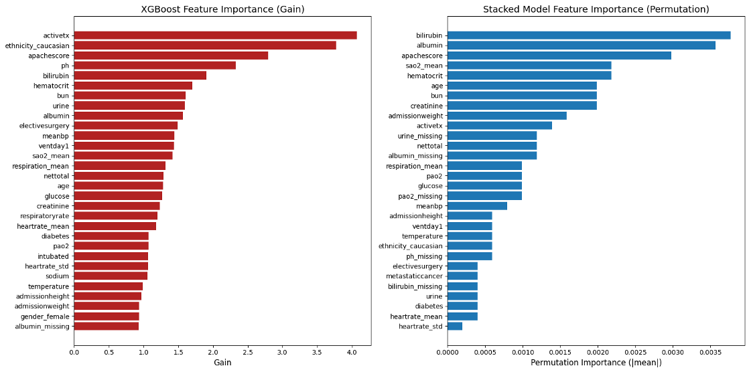
- In simulation, the stacked model trained on balanced data was the most reliable for detecting high-risk patients.
Feature importance plots for both models consistently highlighted clinically reasonable severity markers, including APACHE-related variables and key psychologic measurements, which supports the medical face-validity of the learned patterns. In a small simulation of individual patients, the stacked balanced model was more reliable at correctly flagging high-risk cases that the imbalanced XGBoost model either missed or classified with low confidence. Balanced training helped the models learn minority-class patterns more effectively, but at the cost of more false positives and a departure from the true prevalence of bad outcomes in the ICU.
  - 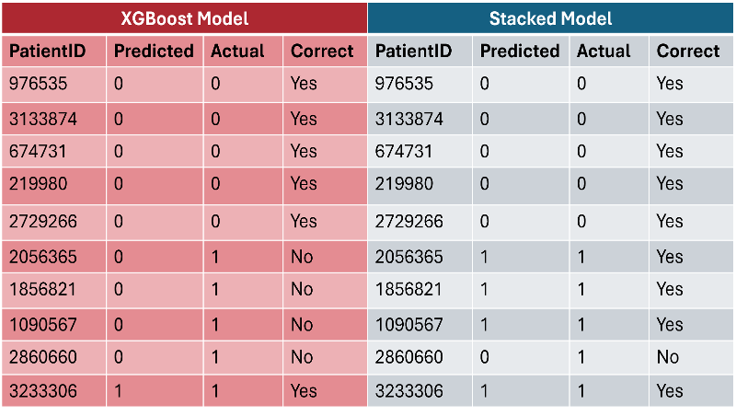
- Balanced training helps the model learn minority-class patterns but breaks real-world prevalence and increases false positives.
- Training choice depends on the goal: balanced for early detection, unbalanced for probability estimation THIS IS MY MOST IMPORTANT LESSON I LEARNED FROM THIS
  - A hybrid approach is effective: unbalanced training + threshold tuning to boost recall without altering prevalence
- XGBoost handled class imbalance naturally due to its tree-based nonlinear structure.
Overall, Objective 1 suggests the best training strategy depends on the goal of the model. When early detection of high-risk patients is the priority, the balanced stacked model is preferred because it substantially reduces missed bad_outcome cases. When realistic probability estimation and preserving true event rates are more important, training on the imbalanced data, and possibly combined with post-hoc threshold tuning may be more appropriate, and XGBoost in particular handled the skewed distribution reasonably well due to its tree-based nonlinear structure.
Objective 2
Before evaluating realism in the models, the first step was to analyze the dataset to identify existing patterns through exploratory data analysis (EDA). It was also necessary to determine which factors should be prioritized for realistic model deployment in an ICU environment. Analysis in Tableau revealed a notable pattern: minority groups displayed higher average lab values, yet patients in these groups were not being diagnosed at comparable rates. This finding marked the beginning of a deeper investigation into potential healthcare disparities. Through EDA, a clearer view of where class imbalance occurs in the dataset emerged, along with insight into which information would be most critical for accurate error analysis.
imbalance lies and what information was crucial for error analysis. 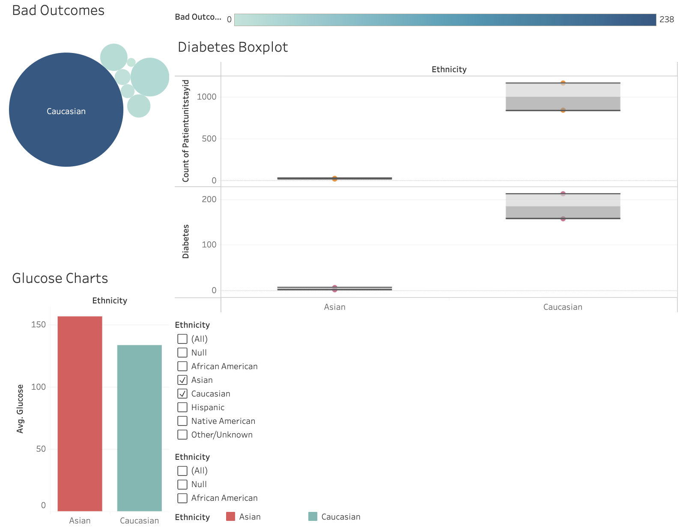
Figure 1: Higher glucose values in Asians but less Asians were being diagnosed with diabetes
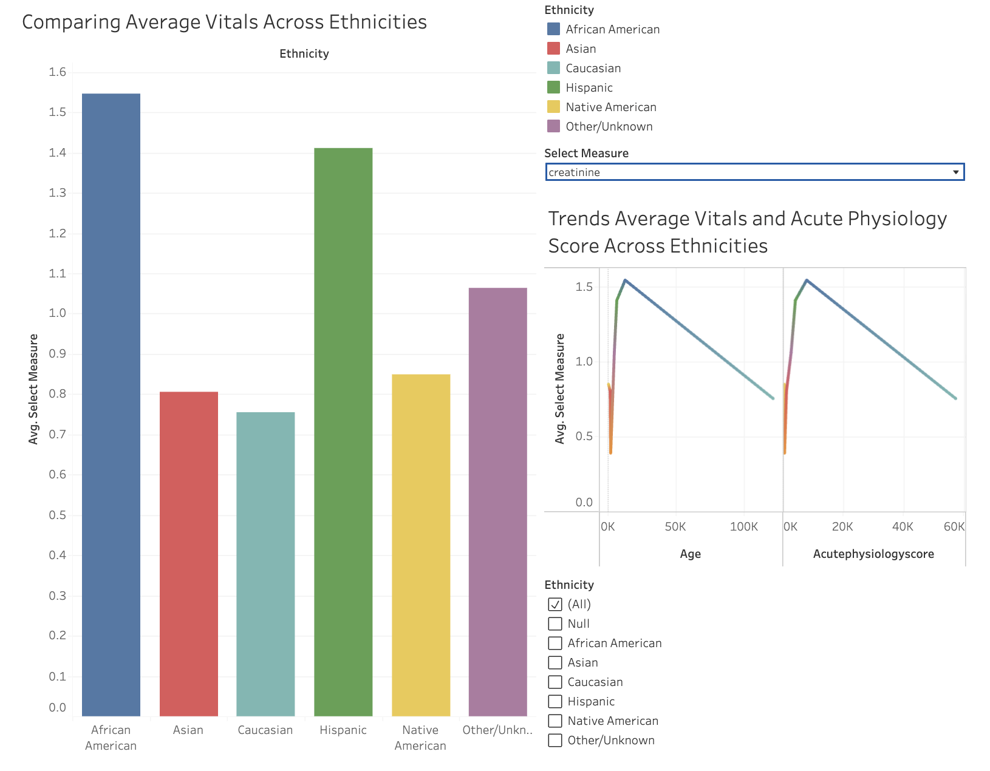
Figure 2: Comparing Average Labs/Vitals across different ethnicities and seeing the discrepancies between Caucasian and other minorities

Objective 3
To evaluate how imbalance-handling strategies affect mortality prediction, both Random Forest (RF) and XGBoost (XGB) were trained using: class-weight balancing and SMOTE oversampling. Each model was tuned using a full threshold sweep by maximizing F1 while maintaining reasonably high recall for the minority (death/1) class.
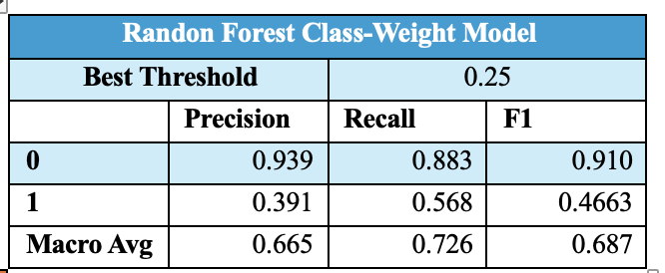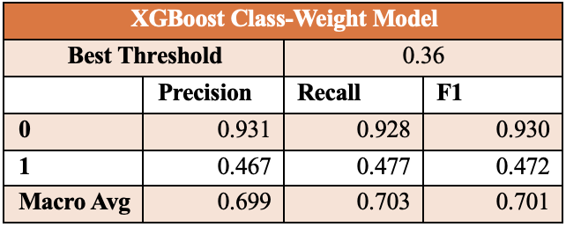
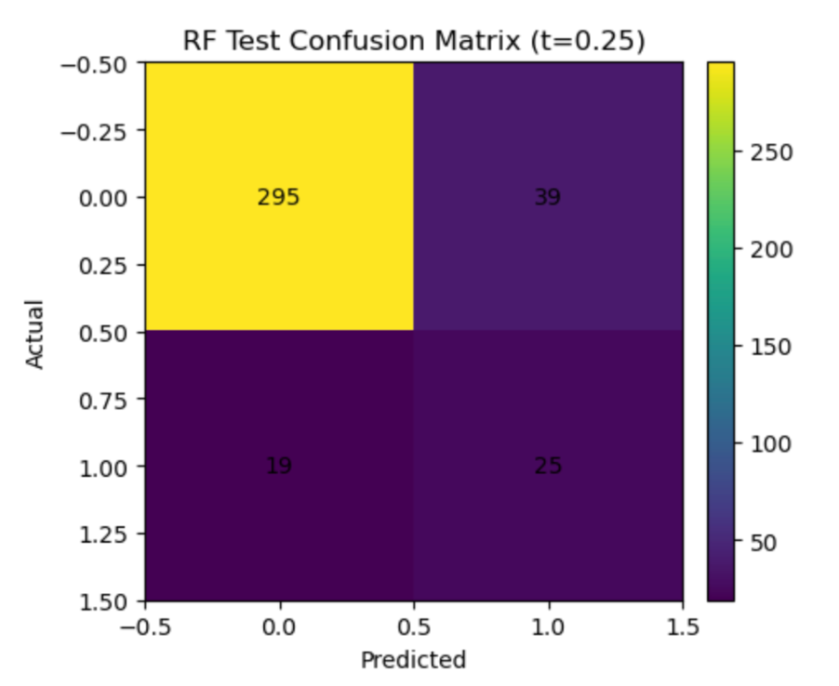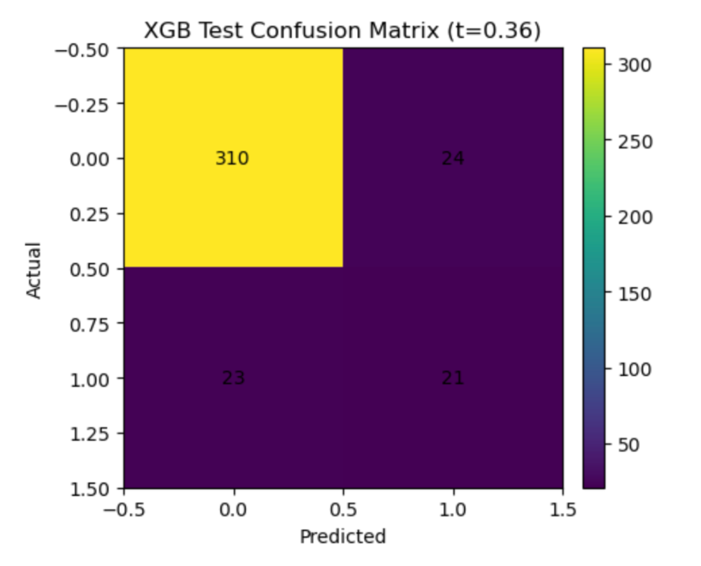
Looking at the class-weight models, Random Forest performed best at the threshold of 0.25, where it achieved higher recall for the minority class and detected more true mortality cases, though at the cost of additional false positives. XGBoost reached its best performance at a threshold of 0.36 and behaved more conservatively, slightly producing higher precision and cleaner predictions but missing more true deaths. In general, class-weighting preserved the original outcome distributions and generated stable realistic confusion matrices for both models.
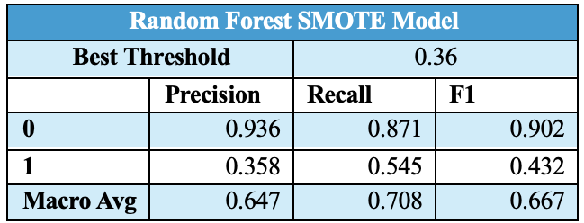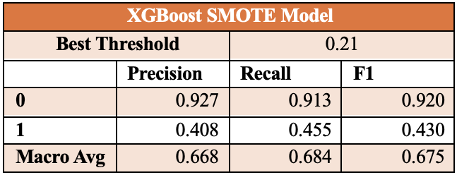
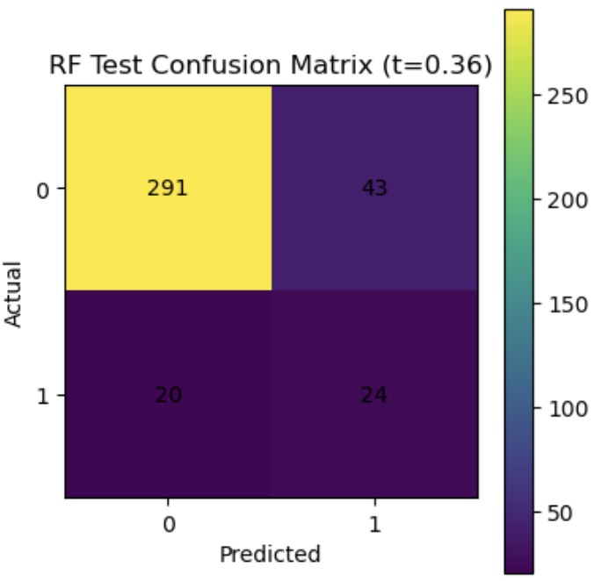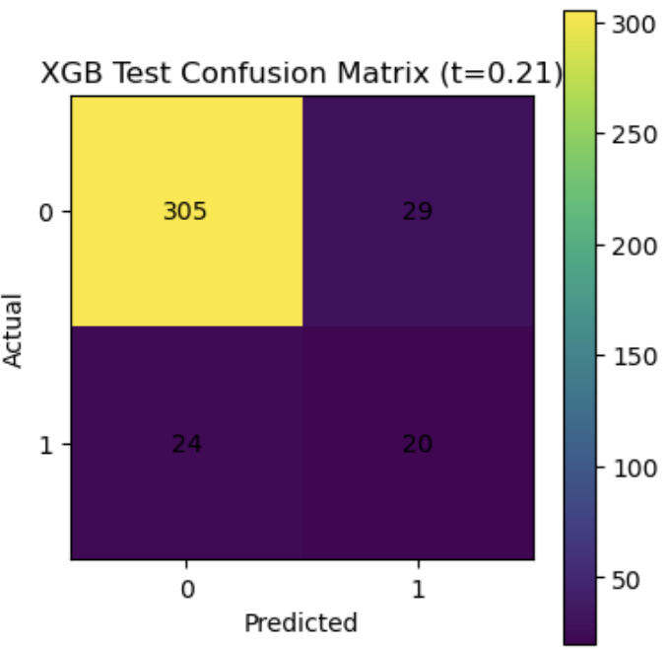
The SMOTE models were more aggressive. Randon Forest performed best at the threshold of 0.36, and XGBoost at 0.21, both requiring lower cutoffs due to the oversampling shifted predicted probabilities upward. SMOTE increases recall for the minority class (1) across both models but reduced precision, leading to more false alarms and greater imbalance between predicted and actual outcome rates. The confusion matrices reflect the shift as well that both models identified more true positives under SMOTE but also made noticeable false positives, suggesting that oversampling made the models more "alarm heavy”.
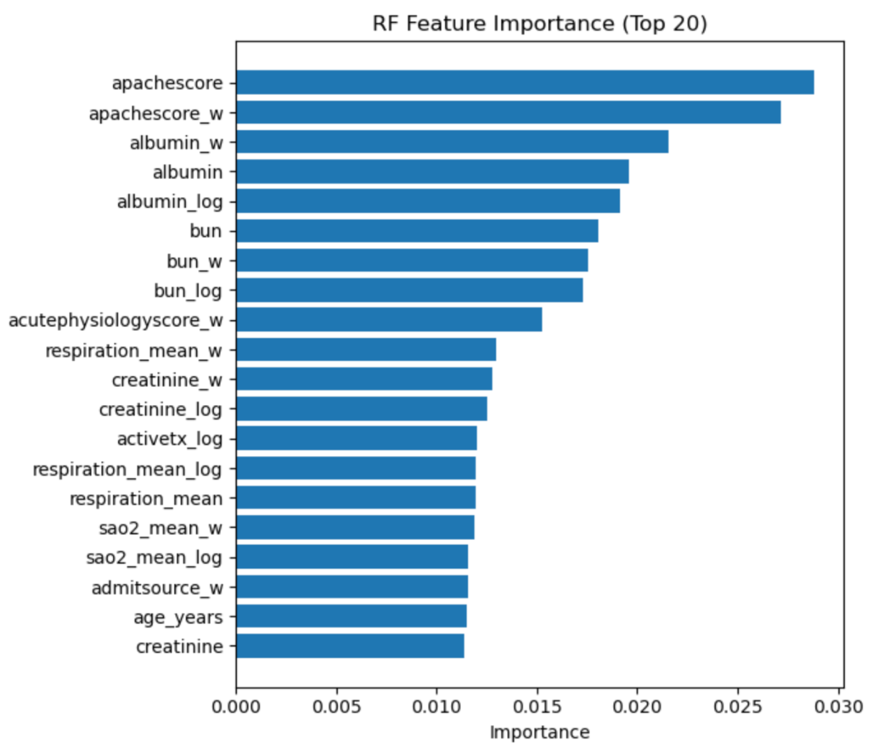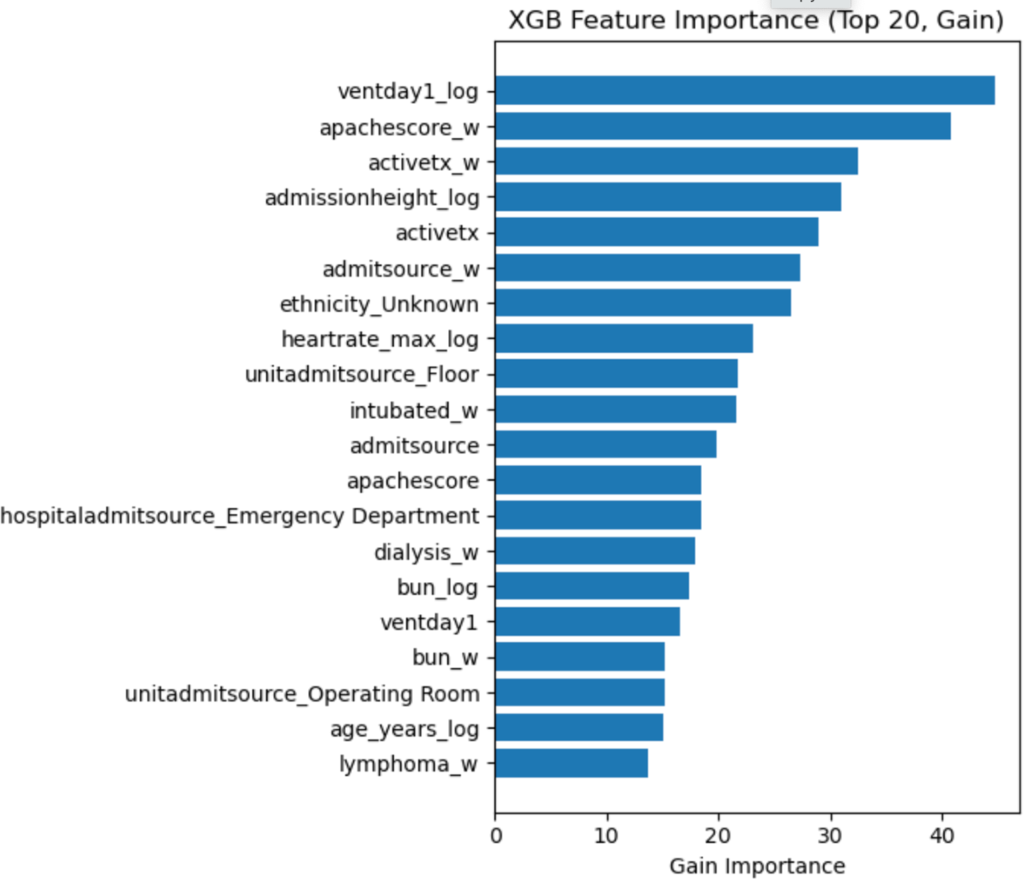
Note. Class-weight models feature importance in the plots above

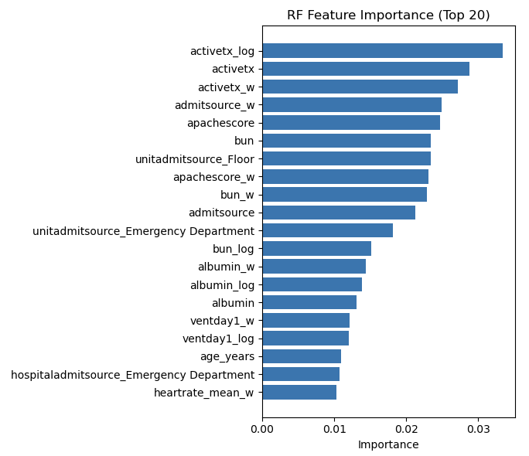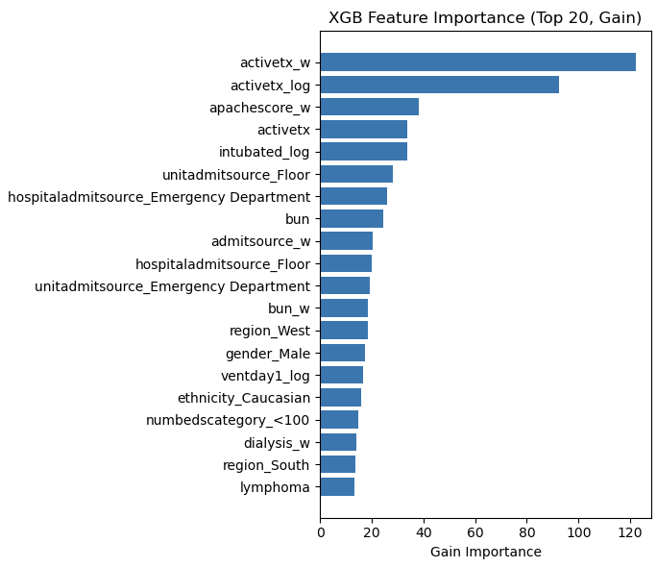
Note. SMOTE models feature importance above
Feature importance patterns remain generally consistent across imbalance strategies. under class-weighting, Random Forest Relied mainly on physiologic severity markers such as APACHE components, renal function labs, albumin, and respiratory parameters, while XGBoost included both severity and early intervention variables, such as ventilation, intubation, and admission source.With SMOTE, the overall structure of important predictors stayed similar, but some intervention related features became more prominent, reflecting the synthetic patterns introduced into the minority class. Class-weight models produce more stable and interpreterable feature rankings, whereas SMOTE led to mild shifts that suggest less reliable underlying patterns.
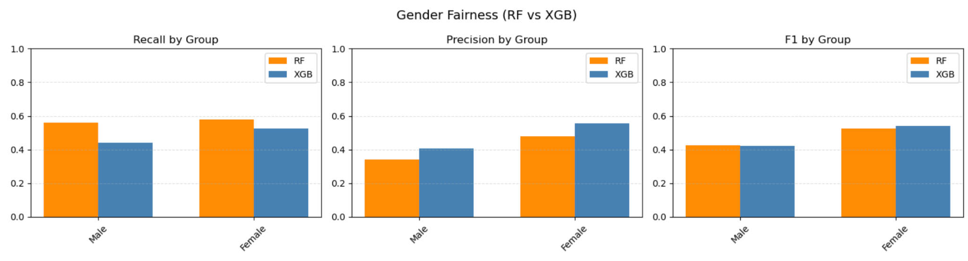
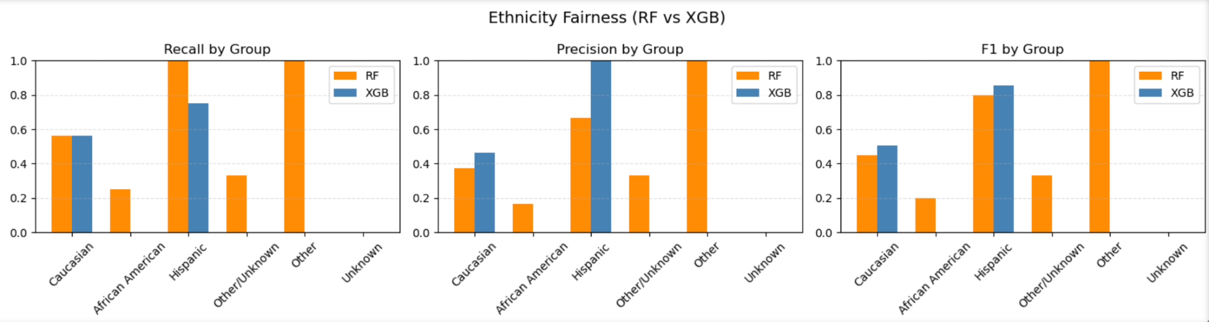
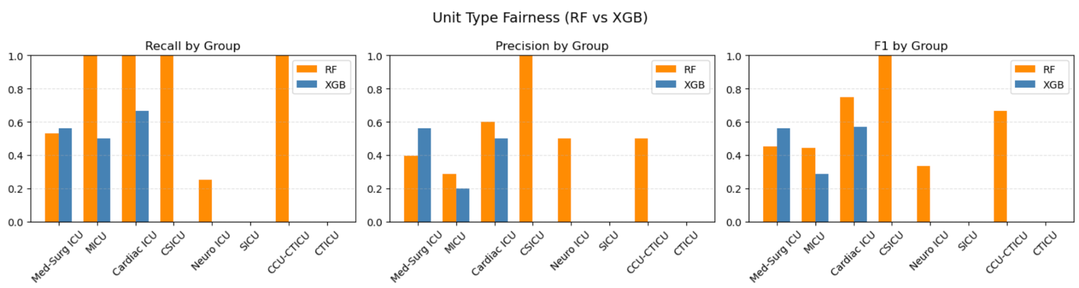
Note. The three plots above include the class-weight models fairness check (Gender, Ethnicity, Unit Type)

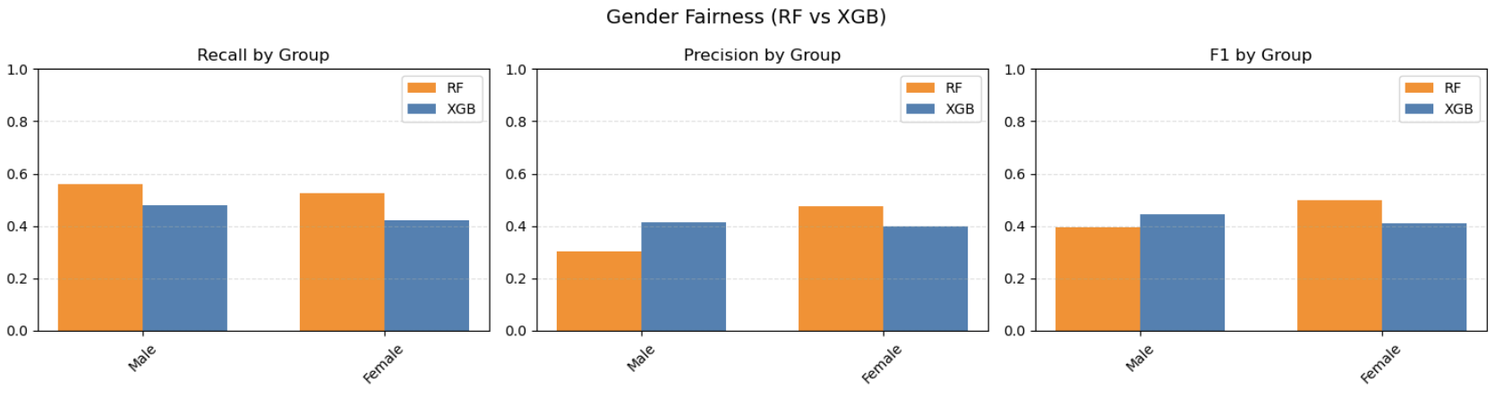
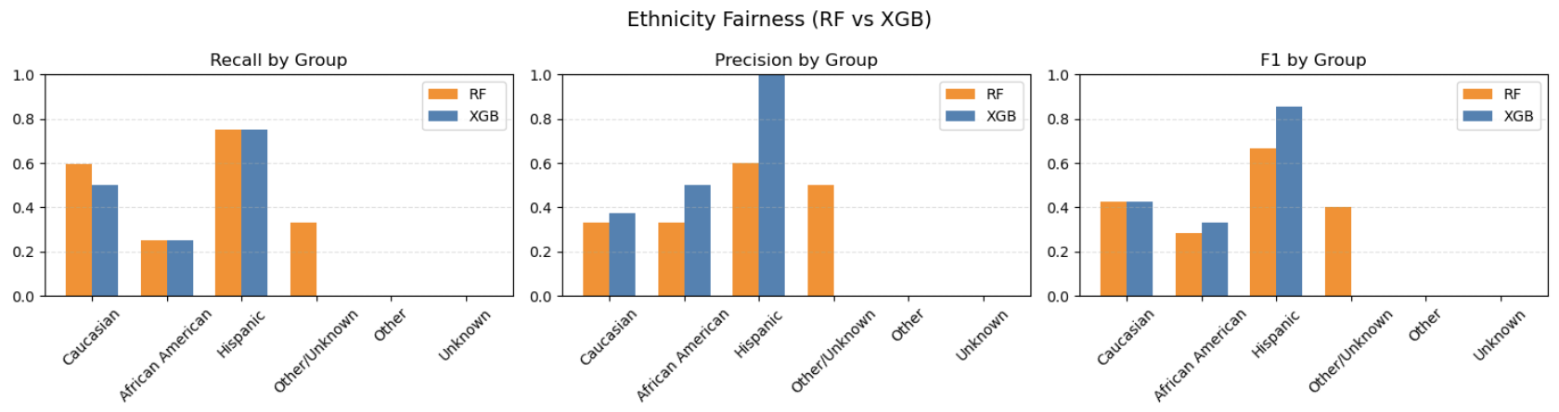
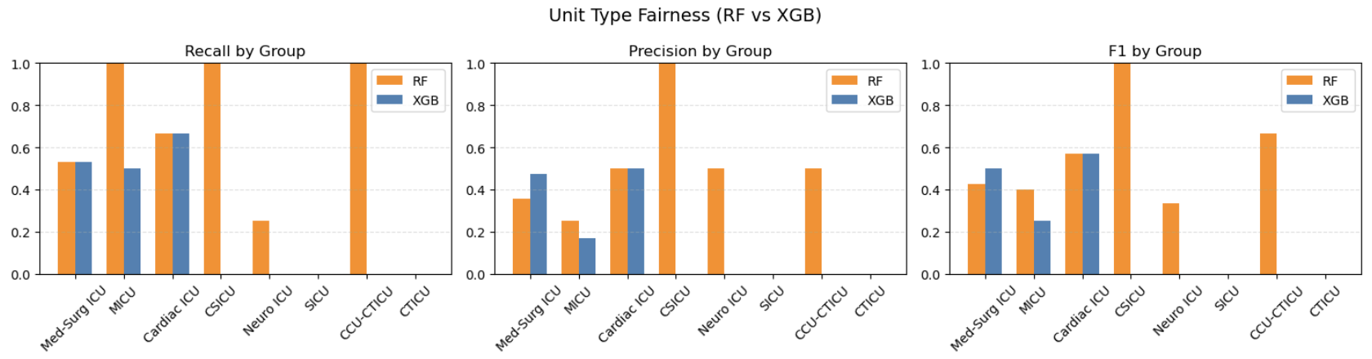
Note. The three plots above include the SMOTE models fairness check (Gender, Ethnicity, Unit Type)
Fairness evaluation showed differences between the two imbalance strategies. In the class-weight models, fairness across gender, ethnicity, and ICU unit types was mostly stable, with minor differences driven largely by small sample sizes rather than systematic model bias. Random Forest tended to have slightly higher recall across groups, and XGBoost showed more balanced precision. Under SMOTE, subgroup performance became a little bit less stable: recall increased broadly across demographic groups, but precision dropped, particularly in smaller subgroups. This caused artificially inflated performance for very small groups, indicating that the synthetic oversampling can exaggerate patterns that do not reflect the real clinical populations.
Conclusion and Future Work
Objective 1
- Balanced preprocessing and modeling strategies significantly improved the detection of high-risk ICU patients while preserving clinical validity in the data.
- The optimal approach depends on the objective: use balanced models for early detection and unbalanced models with threshold tuning for realistic probability estimation.
- For Capstone 2 future work
  - Threshold optimization for unbalanced training
  - Model fine-tuning
  - Multiple iteration (common technique used in medical data)
  - Improve stacked model architecture
  - Expand feature engineering
  - Dimensionality reduction (PCA)
  - Create a simulation dashboard
For Objective 1, the results showed that balancing the data using a stacked model substantially improved detection of high-risk ICU patients while still relying on clinically meaningful predictors. Unbalanced XGBoost patients training achieved impressive overall accuracy but missed many bad_outcome cases, whereas the balanced stacked model traded some precision for much better recall in the minority class (class 1). Together, these findings suggest that there is no single “best” approach: balanced models are better suited for early detection and safety-focused screening, while unbalanced models with careful threshold tuning remain useful when realistic probability estimates and prevalence are more important.
In Capstone 2, Objective 1 wil focus on refining this trade-off rather than choosing one strategy outright. Planned steps include optimizing decision threshold for unbalanced models, fine-tuning hyperparameters, and running multiple training iterations to stabilize performance, more common practices in medical machine-learning pipelines. The team also plans to improve the stacked model, expand feature engineering, explore dimensionality reduction methods such as PCA, and eventually build a simple simulation dashboard.
Objective 2
Ensuring realism in model development requires not only technical rigor but also careful consideration of data integrity, representativeness, and the ethical implications of synthetic augmentation or imbalance-handling methods.
Future work will focus on expanding the dataset to improve demographic representation and reduce the risk of biased predictions. Additional investigation into advanced imbalance-handling techniques, such as probabilistic reweighting, may help preserve clinical realism while improving model performance. Error analysis, including subgroup-specific performance metrics, will also be essential for confirming that models behave equally across populations. The continued evaluation between data science and clinical domain knowledge will be necessary to ensure that predictive models support fair, accurate, and trustworthy outcomes in intensive critical care environments.

Objective 3
Taken together, objective 3 showed that imbalance handling choices meaningfully change how ICU mortality models behave, even when using the same algorithms and features. Class-weighting produces more stable and realistic results, preserving the true outcome distribution while still improving detection of high-risk patients. SMOTE, on the other hand, increased recall and introduced more false positives and caused shifts in feature importance and subgroup stability, suggesting less reliable underlying patterns. But across both models, Random Forest leaned toward higher sensitivity, whileXGBoost offered more precise predictions. Overall, these findings highlight that optimizing for raw performance alone can distort clinical meaning, and imbalance strategies must be chosen with the clinical setting in mind.
In the next phase of the project, we will focus on refining the balance between sensitivity and realistic probability estimation. This will include improving threshold optimization for both SMOTE and class-weighted models so that predictions better reflect real ICU outcome frequencies. We will also explore additional imbalance handling strategies, test multiple training iterations, and perform more careful model fine-tuning to stabilize results. Finally we will plan to expand feature engineering and consider dimensionality reduction methods to reduce the noise and improve generalization. These steps align with the broader Capstone 2 goals and will help integrate all team models into a more reliable clinical pipeline.

References
Ali, A. H. D., Harun, S. N., Othman, N., Ibrahim, B., Elhag, O. E., Abdulbagi, I., & Abdullah, I. A. (2025). Discriminatory performance of APACHE II score and the prediction of mortality within the ICU in patients with sepsis admitted to the ICU. Materia Socio-Medica, 37(2), 153–158. https://doi.org/10.5455/msm.2025.37.153-158​
Iwase, S., Nakada, T., Shimada, T., Oami, T., Shimazui, T., Takahashi, N., Yamabe, J., Yamao, Y., & Kawakami, E. (2022). Prediction algorithm for ICU mortality and length of stay using machine learning. Scientific Reports, 12, Article 12912. https://doi.org/10.1038/s41598-022-17091-5​
Johnson, A., Pollard, T., Badawi, O., & Raffa, J. (2021). eICU Collaborative Research Database Demo (version 2.0.1). PhysioNet. https://doi.org/10.13026/4mxk-na84​
Kawasaki, E., Iwase, S., Nakada, T., Shimada, T., Oami, T., Shimazui, T., Takahashi, N., Yamabe, J., Yamao, Y., & Kawakami, E. (2020). Machine learning for ICU mortality risk. Scientific Reports, 10, Article 12912. https://doi.org/10.1038/s41598-020-78184-7​
Safaei, N., Safaei, B., Seyedekrami, S. S., Talafidaryani, M., Masoud, A., Wang, S., Li, Q., & Moqri, M. (2022). E‑CatBoost: An efficient machine learning framework for predicting ICU mortality using the eICU Collaborative Research Database. PLOS ONE, 17(5), e0262895. https://doi.org/10.1371/journal.pone.0262895​
Yun, H., Choi, J., & Park, J. H. (2021). Prediction of critical care outcome for adult patients presenting to emergency department using initial triage information: An XGBoost algorithm analysis. JMIR Medical Informatics, 9(9), e30770. https://doi.org/10.2196/30770​
Zhang, Q.-F., Zhang, S.-L., Li, G., Guo, M., Qi, X.-X., Xing, X.-H., & Wang, Z. (2025). Prognostic value of lactate clearance, fluid balance, and APACHE II score in patients with cardiogenic shock receiving extracorporeal membrane oxygenation. Frontiers in Cardiovascular Medicine, 12, 1557909. https://doi.org/10.3389/fcvm.2025.1557909

